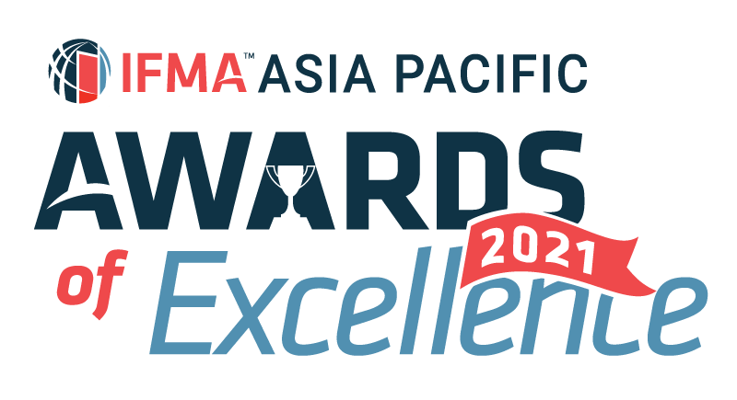

IFMA Asia Pacific Award of Excellence 2021
Asia Pacific Facility Manager of the Year
Nominator’s information:
Salutation:
Full Name:
IFMA Membership No:
Company Name:
Title/Position:
Email: |  | Phone:

Nominee’s information:
Salutation:
Full Name:
IFMA Membership No:
Company Name:
Title/Position:
Email: |  | Phone:

Information on Winner’s trophy/ certificate
Awardee:
(Max 40 characters)

Written description about the submission and how it fulfils the judging criteria
1. Describe the nominee’s career to date and qualifications. (10%)

Word Count (Q1) :
2. Summarize how the nominee sustain functionality of the built environment by integrating people, place, process and technology. (20%)
- (Core Competencies of FM: Communication, Emergency Preparedness and Business Continuity, Environmental Stewardship and Sustainability, Finance and Business, Human Factors, Leadership and Strategy, Operations and Maintenance, Project Management, Quality, Real Estate and Property Management and Technology)

Word Count (Q2) :
3. Substantiate the nominee’s contribution to the success of the organization, quantifying where possible. (20%)

Word Count (Q3) :
4. Describe how the nominee has committed to serve and contributed to the IFMA and enhanced the value proposition of the Association. (25%)

Word Count (Q4) :
5. What are the most significant contributions to IFMA and the facility management profession and that distinguishes the nominee and entitles him/her to receive this honor? (25%)

Word Count (Q5) :
Word Count (Q1-Q5) :
* Jurors will only judge the first 1,000 words of your submission

SUBMISSION CRITERIA
Written Submission : Overall submission should be within 1,000 text in WORD format using prescribed template provided. Jurors will only assess the first 1,000 text. No picture, photograph or graphic in written submission. Footnote will also be included in text count.
Attachments : A maximum of 5 pages of attachments (A4 single-sided for each page) in PDF format and 3 testimonials (maximum 2 pages per testimonial, A4 single-sided for each page) in PDF format you believe will support your entry and help judges to understand your project.
Language : Please write your submission in ENGLISH.
Deadline : All submissions should be emailed to IFMA Hong Kong Chapter Administrator at email hk-ifma.administrator@ifma.org.hk by Monday, December 6, 2021, 23:59 p.m. Hong Kong Time to be considered.
I agree IFMA has the right to use my name and information in this form as it relates to the promotion of this award. I understand the award can be published in IFMA and other trade publications.

