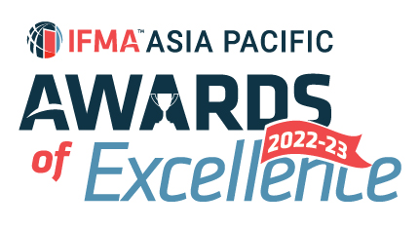

IFMA Asia Pacific Award of Excellence (2022-2023)
Asia Pacific Facility Management Associate Partner of the Year
Nominator’s information:
Salutation:
Full Name:
IFMA Membership No:
Company Name:
Title/Position:
Email: |  | Phone:

Nominee’s information
Company Name:
Project 1
Project:
Location / Address:
Contact Person:
Title/Position:
Email: |  | Phone:
Project 2
Project:
Location / Address:
Contact Person:
Title/Position:
Email: |  | Phone:
Project 3
Project:
Location / Address:
Contact Person:
Title/Position:
Email: |  | Phone:
*nomination must be based on either 1 specific project or maximum of 3 projects
Information on Winner’s trophy/ certificate
Awarded Company
(Max 45 characters)
Project Name:
(Max 45 characters)
Written description about the submission and how it fulfils the judging criteria
1. Describe mission and vision of the company and how the service or product was developed. (15%)

Word Count (Q1) :
2. What was the opportunity identified in the FM operation and how did the service or product enhance FM service quality and overall scorecard? (25%)

Word Count (Q2) :
3. Give example of the achievements in past 24 months and how to validate results. (25%)

Word Count (Q3) :
4. Adaptability of the service or product to different FM operation models. (20%)

Word Count (Q4) :
5. Identify area of improvement from existing service or product and what is the development roadmap (15%)

Word Count (Q5) :
Word Count (Q1-Q5) :
* Jurors will only judge the first 1,000 words of your submission

SUBMISSION CRITERIA
Written Submission : Overall submission should be within 1,000 text in WORD format using prescribed template provided. Jurors will only assess the first 1,000 text. No picture, photograph or graphic in written submission. Footnote will also be included in text count. Submittal covers activities from 1 April 2022 to 31 March 2023.
Attachments : A maximum of 5 pages of attachments (A4 single-sided for each page) in PDF format and 3 testimonials (maximum 2 pages per testimonial, A4 single-sided for each page) in PDF format you believe will support your entry and help judges to understand your project.
Language : Please write your submission in ENGLISH.
Deadline : All submissions should be emailed to IFMA Hong Kong Chapter Administrator at email awards@ifma.org.hk by Saturday, 15 April 2023, 23:59 p.m Hong Kong Time to be considered.

I agree IFMA has the right to use my name and information in this form as it relates to the promotion of this award. I understand the award can be published in IFMA and other trade publications.

