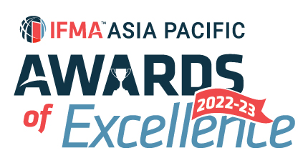

IFMA Asia Pacific Award of Excellence (2022-2023)
Asia Pacific Facility Manager of the Year
Nominator’s information:
Salutation:
Full Name:
IFMA Membership No:
Company Name:
Title/Position:
Email: |  | Phone:

Nominee’s information:
Salutation:
Full Name:
IFMA Membership No:
Company Name:
Title/Position:
Email: |  | Phone:

Information on Winner’s trophy/ certificate
Awardee:
(Max 40 characters)

Written description about the submission and how it fulfils the judging criteria
1. Describe the nominee’s career to date and qualifications. (15%)

Word Count (Q1) :
2. Describe the nominee's significant facilities related work accomplishment and leadership (20%)

Word Count (Q2) :
3. List the nominee's IFMA involvement. (30%)
- Dates (Year to Year)
- Components: chapter/councils/communities
- Position held

Word Count (Q3) :
4. Describe the nominee's IFMA contribution and leadership. (30%)

Word Count (Q4) :
5. Describe the nominee's other association involvement, positions held and contribution (5%)

Word Count (Q5) :
Word Count (Q1-Q5) :
* Jurors will only judge the first 1,000 words of your submission

SUBMISSION CRITERIA
Written Submission : Overall submission should be within 1,000 text in WORD format using prescribed template provided. Jurors will only assess the first 1,000 text. No picture, photograph or graphic in written submission. Footnote will also be included in text count. Submittal covers activities from 1 April 2022 to 31 March 2023.
Attachments : A maximum of 5 pages of attachments (A4 single-sided for each page) in PDF format and 3 testimonials (maximum 2 pages per testimonial, A4 single-sided for each page) in PDF format you believe will support your entry and help judges to understand your project.
Language : Please write your submission in ENGLISH.
Deadline : All submissions should be emailed to IFMA Hong Kong Chapter Administrator at email awards@ifma.org.hk by Saturday, 15 April 2023, 23:59 p.m Hong Kong Time to be considered.
I agree IFMA has the right to use my name and information in this form as it relates to the promotion of this award. I understand the award can be published in IFMA and other trade publications.

