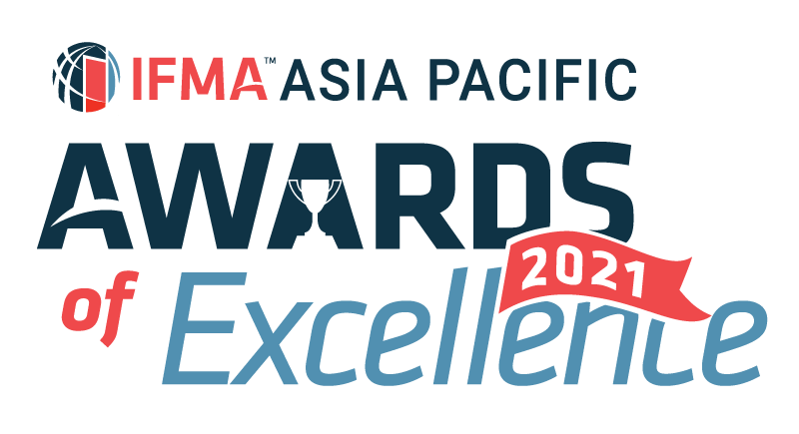

IFMA Asia Pacific Award of Excellence 2021
Asia Pacific Facility Management Outsource Service Provider of the Year
Nominator’s information:
Salutation:
Full Name:
IFMA Membership No:
Company Name:
Title/Position:
Email: |  | Phone:

Nominee’s information
Company Name:
Project 1
Project:
Location / Address:
Contact Person:
Title/Position:
Email: |  | Phone:
Project 2
Project:
Location / Address:
Contact Person:
Title/Position:
Email: |  | Phone:
Project 3
Project:
Location / Address:
Contact Person:
Title/Position:
Email: |  | Phone:
*nomination must be based on either 1 specific project or maximum of 3 projects
Information on Winner’s trophy/ certificate
Awarded Company
(Max 45 characters)
Project Name:
(Max 45 characters)
Written description about the submission and how it fulfils the judging criteria
1.Describe your talent recruitment process introducing FM as a career of choice. (10%)
- Career talk in schools and colleges
- IFMA's Facility Management Graduate (FMG) program / Youth support program

Word Count (Q1) :
2.Describe your management trainee program. Percentage of trainees stay to serve the company on completion of the program. (10%)
- Would you encourage staff to internal transfer to other team or other countries on their request?
- Have you provided mentorship program for staff to learn under the wing of senior executives?

Word Count (Q2) :
3.How would you keep current on changes in facility management profession and educate team members at all levels. (10%)
- Describe current training program
- Champion Essential of FM (EoFM), Facility Management Professional® (FMP®), Sustainability Facility Professional® (SFP®), Certified Facility Manager® (CFM®)?
- Bonus : How many percent of member in your company are IFMA member? (Max. 5)

Word Count (Q3) :
4.Have you adopt IFMA's Facility Management Training and Development Framework in your people development process? Please give example. (5%)

Word Count (Q4) :
5. How would you ensure delivery of committed scopes, above and beyond client's target? (20%)
- Give example of replicating successful best practice in different client account.

Word Count (Q5) :
6. Client management and CSR. (25%)
- Give example how you have successfully build relationship with your client and result of such relationship.
- Give example of your continuous involvement in the community.

Word Count (Q6) :
7.Elaborate your audit and reporting, risk management and corrective action plan. (20%)
- Give example of lessons learnt from incident that had been successfully developed into improvement initiative and recognized by client.

Word Count (Q7) :
Word Count (Q1-Q7) :
* Jurors will only judge the first 1,000 words of your submission

SUBMISSION CRITERIA
Written Submission : Overall submission should be within 1,000 text in WORD format using prescribed template provided. Jurors will only assess the first 1,000 text. No picture, photograph or graphic in written submission. Footnote will also be included in text count.
Attachments : A maximum of 5 pages of attachments (A4 single-sided for each page) in PDF format and 3 testimonials (maximum 2 pages per testimonial, A4 single-sided for each page) in PDF format you believe will support your entry and help judges to understand your project.
Language : Please write your submission in ENGLISH.
Deadline : All submissions should be emailed to IFMA Hong Kong Chapter Administrator at email hk-ifma.administrator@ifma.org.hk by Friday, October 29, 2021, 5:00 p.m. Hong Kong Time to be considered.

I agree IFMA has the right to use my name and information in this form as it relates to the promotion of this award. I understand the award can be published in IFMA and other trade publications.

