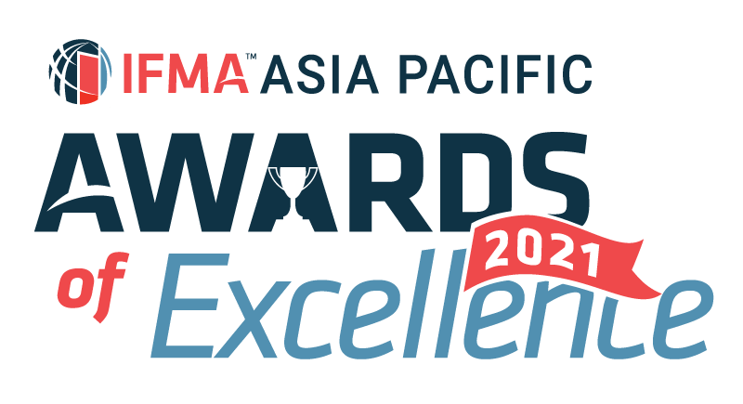

IFMA Asia Pacific Award of Excellence 2021
Asia Pacific Innovation Award
Nominator’s information:
Salutation:
Full Name:
IFMA Membership No:
Company Name:
Title/Position:
Email: |  | Phone:

Nominee’s information
Company Name:
Project 1
Project:
Location / Address:
Contact Person:
Title/Position:
Email: |  | Phone:
Project 2
Project:
Location / Address:
Contact Person:
Title/Position:
Email: |  | Phone:
Project 3
Project:
Location / Address:
Contact Person:
Title/Position:
Email: |  | Phone:
*nomination must be based on either 1 specific project or maximum of 3 projects
Information on Winner’s trophy/ certificate
Awarded Company
(Max 45 characters)
Project Name:
(Max 45 characters)
Written description about the submission and how it fulfils the judging criteria
1.How would you define innovation in the management of facilities? What makes your project representative of Innovation in terms of creativity, quality and innovation within the context of advancing and promoting facility management in the region? (20%)

Word Count (Q1) :
2.Did this innovative project provide benefits to the business, the people in the facility or the FM profession? (20%)

Word Count (Q2) :
3.Were there special circumstances that allowed you to implement this innovation (access to finances, unique building characteristics, enlightened senior management, et al)? Regardless if there were special circumstances, could this innovation be replicated by any Facility Manager? Please explain. (15%)

Word Count (Q3) :
4.What motivated the investigation/implementation of this innovation? Please explain the development of this project. (15%)

Word Count (Q4) :
5.Does this innovation reflect current trends in Facility Management, as defined by IFMA, or does it pave the way for a new trend in the profession? (15%)

Word Count (Q5) :
6.How was this innovation received by the stakeholders within your organization? What challenges did you face when implementing this innovation? How were they met and resolved? (15%)

Word Count (Q6) :
Word Count (Q1-Q6) :
* Jurors will only judge the first 1,000 words of your submission

SUBMISSION CRITERIA
Written Submission : Overall submission should be within 1,000 text in WORD format using prescribed template provided. Jurors will only assess the first 1,000 text. No picture, photograph or graphic in written submission. Footnote will also be included in text count.
Attachments : A maximum of 5 pages of attachments (A4 single-sided for each page) in PDF format and 3 testimonials (maximum 2 pages per testimonial, A4 single-sided for each page) in PDF format you believe will support your entry and help judges to understand your project.
Language : Please write your submission in ENGLISH.
Deadline : All submissions should be emailed to IFMA Hong Kong Chapter Administrator at email hk-ifma.administrator@ifma.org.hk by Friday, October 29, 2021, 5:00 p.m. Hong Kong Time to be considered.

I agree IFMA has the right to use my name and information in this form as it relates to the promotion of this award. I understand the award can be published in IFMA and other trade publications.

